TRAIN_SEAT

ekran görüntüsü, metin, yazılım, multimedya yazılımı içeren bir resim

Açıklama otomatik olarak oluşturulduekran görüntüsü, metin, yazılım, multimedya yazılımı içeren bir resim

Açıklama otomatik olarak oluşturulduekran görüntüsü, metin, yazılım, multimedya yazılımı içeren bir resim

Açıklama otomatik olarak oluşturulduekran görüntüsü, metin, yazılım, multimedya yazılımı içeren bir resim

Açıklama otomatik olarak oluşturulduekran görüntüsü, metin, yazılım, multimedya yazılımı içeren bir resim

Açıklama otomatik olarak oluşturulduekran görüntüsü, metin, yazılım, multimedya yazılımı içeren bir resim

Açıklama otomatik olarak oluşturuldu

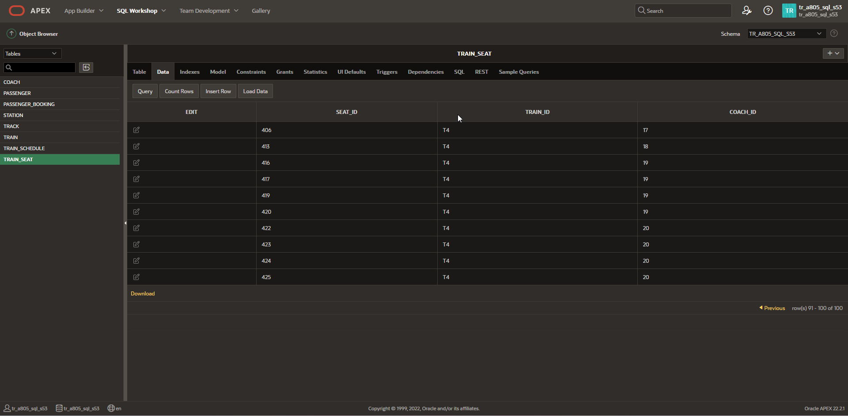

INSERT INTO TRAIN_SEAT VALUES

(101,'T1',1);

INSERT INTO TRAIN_SEAT VALUES

(102,'T1',1);

INSERT INTO TRAIN_SEAT VALUES

(103,'T1',1);

INSERT INTO TRAIN_SEAT VALUES

(104,'T1',1);

INSERT INTO TRAIN_SEAT VALUES

(105,'T1',1);

INSERT INTO TRAIN_SEAT VALUES

(106,'T1',2);

INSERT INTO TRAIN_SEAT VALUES

(107,'T1',2);

INSERT INTO TRAIN_SEAT VALUES

(108,'T1',2);

INSERT INTO TRAIN_SEAT VALUES

(109,'T1',2);

INSERT INTO TRAIN_SEAT VALUES

(110,'T1',2);

INSERT INTO TRAIN_SEAT VALUES

(111,'T1',3);

INSERT INTO TRAIN_SEAT VALUES

(112,'T1',3);

INSERT INTO TRAIN_SEAT VALUES

(113,'T1',3);

INSERT INTO TRAIN_SEAT VALUES

(114,'T1',3);

INSERT INTO TRAIN_SEAT VALUES

(115,'T1',3);

INSERT INTO TRAIN_SEAT VALUES

(116,'T1',4);

INSERT INTO TRAIN_SEAT VALUES

(117,'T1',4);

INSERT INTO TRAIN_SEAT VALUES

(118,'T1',4);

INSERT INTO TRAIN_SEAT VALUES

(119,'T1',4);

INSERT INTO TRAIN_SEAT VALUES

(120,'T1',4);

INSERT INTO TRAIN_SEAT VALUES

(121,'T1',5);

INSERT INTO TRAIN_SEAT VALUES

(122,'T1',5);

INSERT INTO TRAIN_SEAT VALUES

(123,'T1',5);

INSERT INTO TRAIN_SEAT VALUES

(124,'T1',5);

INSERT INTO TRAIN_SEAT VALUES

(125,'T1',5);

INSERT INTO TRAIN_SEAT VALUES

(201,'T2',6);

INSERT INTO TRAIN_SEAT VALUES

(202,'T2',6);

INSERT INTO TRAIN_SEAT VALUES

(203,'T2',6);

INSERT INTO TRAIN_SEAT VALUES

(204,'T2',6);

INSERT INTO TRAIN_SEAT VALUES

(205,'T2',6);

INSERT INTO TRAIN_SEAT VALUES

(206,'T2',7);

INSERT INTO TRAIN_SEAT VALUES

(207,'T2',7);

INSERT INTO TRAIN_SEAT VALUES

(208,'T2',7);

INSERT INTO TRAIN_SEAT VALUES

(209,'T2',7);

INSERT INTO TRAIN_SEAT VALUES

(210,'T2',7);

INSERT INTO TRAIN_SEAT VALUES

(211,'T2',8);

INSERT INTO TRAIN_SEAT VALUES

(212,'T2',8);

INSERT INTO TRAIN_SEAT VALUES

(213,'T2',8);

INSERT INTO TRAIN_SEAT VALUES

(214,'T2',8);

INSERT INTO TRAIN_SEAT VALUES

(215,'T2',8);

INSERT INTO TRAIN_SEAT VALUES

(216,'T2',9);

INSERT INTO TRAIN_SEAT VALUES

(217,'T2',9);

INSERT INTO TRAIN_SEAT VALUES

(218,'T2',9);

INSERT INTO TRAIN_SEAT VALUES

(219,'T2',9);

INSERT INTO TRAIN_SEAT VALUES

(220,'T2',9);

INSERT INTO TRAIN_SEAT VALUES

(221,'T2',10);

INSERT INTO TRAIN_SEAT VALUES

(222,'T2',10);

INSERT INTO TRAIN_SEAT VALUES

(223,'T2',10);

INSERT INTO TRAIN_SEAT VALUES

(224,'T2',10);

INSERT INTO TRAIN_SEAT VALUES

(225,'T2',10);

INSERT INTO TRAIN_SEAT VALUES

(301,'T3',11);

INSERT INTO TRAIN_SEAT VALUES

(302,'T3',11);

INSERT INTO TRAIN_SEAT VALUES

(303,'T3',11);

INSERT INTO TRAIN_SEAT VALUES

(304,'T3',11);

INSERT INTO TRAIN_SEAT VALUES

(305,'T3',11);

INSERT INTO TRAIN_SEAT VALUES

(306,'T3',12);

INSERT INTO TRAIN_SEAT VALUES

(307,'T3',12);

INSERT INTO TRAIN_SEAT VALUES

(308,'T3',12);

INSERT INTO TRAIN_SEAT VALUES

(309,'T3',12);

INSERT INTO TRAIN_SEAT VALUES

(310,'T3',12);

INSERT INTO TRAIN_SEAT VALUES

(311,'T3',13);

INSERT INTO TRAIN_SEAT VALUES

(312,'T3',13);

INSERT INTO TRAIN_SEAT VALUES

(313,'T3',13);

INSERT INTO TRAIN_SEAT VALUES

(314,'T3',13);

INSERT INTO TRAIN_SEAT VALUES

(315,'T3',13);

INSERT INTO TRAIN_SEAT VALUES

(316,'T3',14);

INSERT INTO TRAIN_SEAT VALUES

(317,'T3',14);

INSERT INTO TRAIN_SEAT VALUES

(318,'T3',14);

INSERT INTO TRAIN_SEAT VALUES

(319,'T3',14);

INSERT INTO TRAIN_SEAT VALUES

(320,'T3',14);

INSERT INTO TRAIN_SEAT VALUES

(321,'T3',15);

INSERT INTO TRAIN_SEAT VALUES

(322,'T3',15);

INSERT INTO TRAIN_SEAT VALUES

(323,'T3',15);

INSERT INTO TRAIN_SEAT VALUES

(324,'T3',15);

INSERT INTO TRAIN_SEAT VALUES

(325,'T3',15);

INSERT INTO TRAIN_SEAT VALUES

(401,'T4',16);

INSERT INTO TRAIN_SEAT VALUES

(402,'T4',16);

INSERT INTO TRAIN_SEAT VALUES

(403,'T4',16);

INSERT INTO TRAIN_SEAT VALUES

(404,'T4',16);

INSERT INTO TRAIN_SEAT VALUES

(405,'T4',16);

INSERT INTO TRAIN_SEAT VALUES

(406,'T4',17);

INSERT INTO TRAIN_SEAT VALUES

(407,'T4',17);

INSERT INTO TRAIN_SEAT VALUES

(408,'T4',17);

INSERT INTO TRAIN_SEAT VALUES

(409,'T4',17);

INSERT INTO TRAIN_SEAT VALUES

(410,'T4',17);

INSERT INTO TRAIN_SEAT VALUES

(411,'T4',18);

INSERT INTO TRAIN_SEAT VALUES

(412,'T4',18);

INSERT INTO TRAIN_SEAT VALUES

(413,'T4',18);

INSERT INTO TRAIN_SEAT VALUES

(414,'T4',18);

INSERT INTO TRAIN_SEAT VALUES

(415,'T4',18);

INSERT INTO TRAIN_SEAT VALUES

(416,'T4',19);

INSERT INTO TRAIN_SEAT VALUES

(417,'T4',19);

INSERT INTO TRAIN_SEAT VALUES

(418,'T4',19);

INSERT INTO TRAIN_SEAT VALUES

(419,'T4',19);

INSERT INTO TRAIN_SEAT VALUES

(420,'T4',19);

INSERT INTO TRAIN_SEAT VALUES

(421,'T4',20);

INSERT INTO TRAIN_SEAT VALUES

(422,'T4',20);

INSERT INTO TRAIN_SEAT VALUES

(423,'T4',20);

INSERT INTO TRAIN_SEAT VALUES

(424,'T4',20);

INSERT INTO TRAIN_SEAT VALUES

(425,'T4',20);

TRAIN_SCHEDULE

ekran görüntüsü, metin, yazılım, multimedya yazılımı içeren bir resim

Açıklama otomatik olarak oluşturulduekran görüntüsü, metin, yazılım, multimedya yazılımı içeren bir resim

Açıklama otomatik olarak oluşturuldu

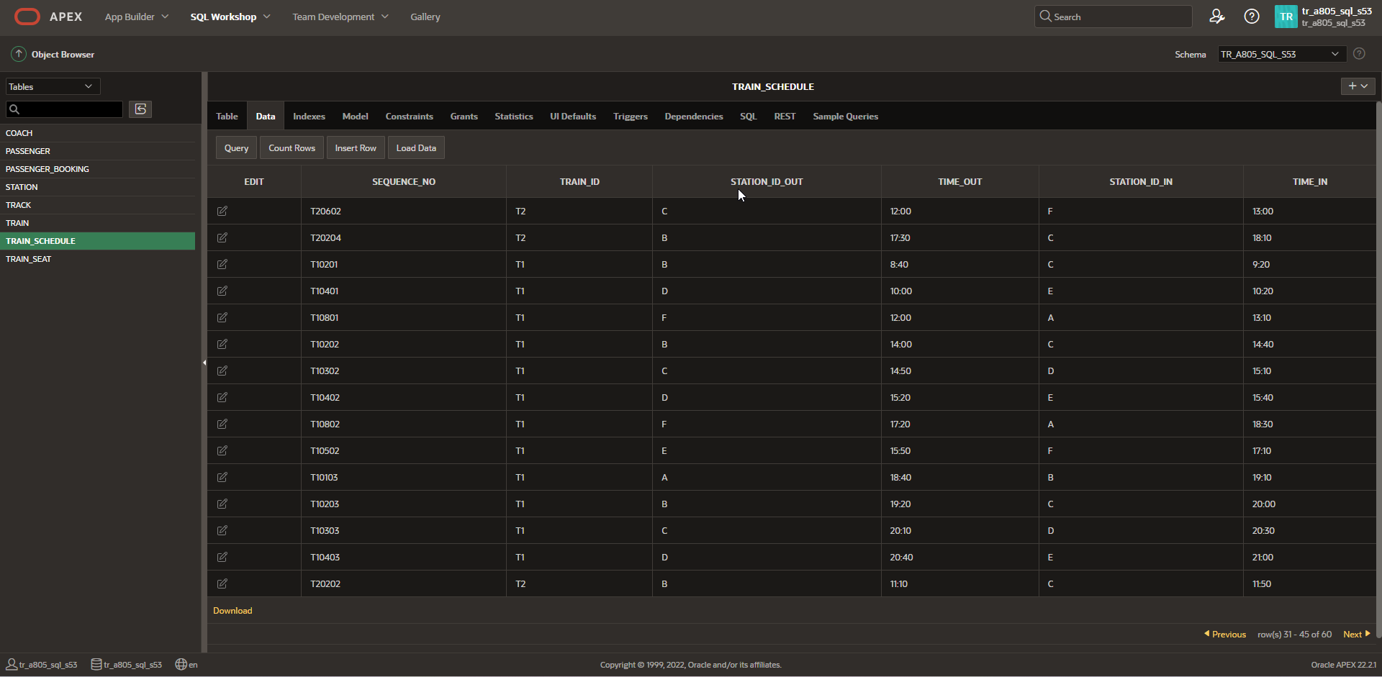

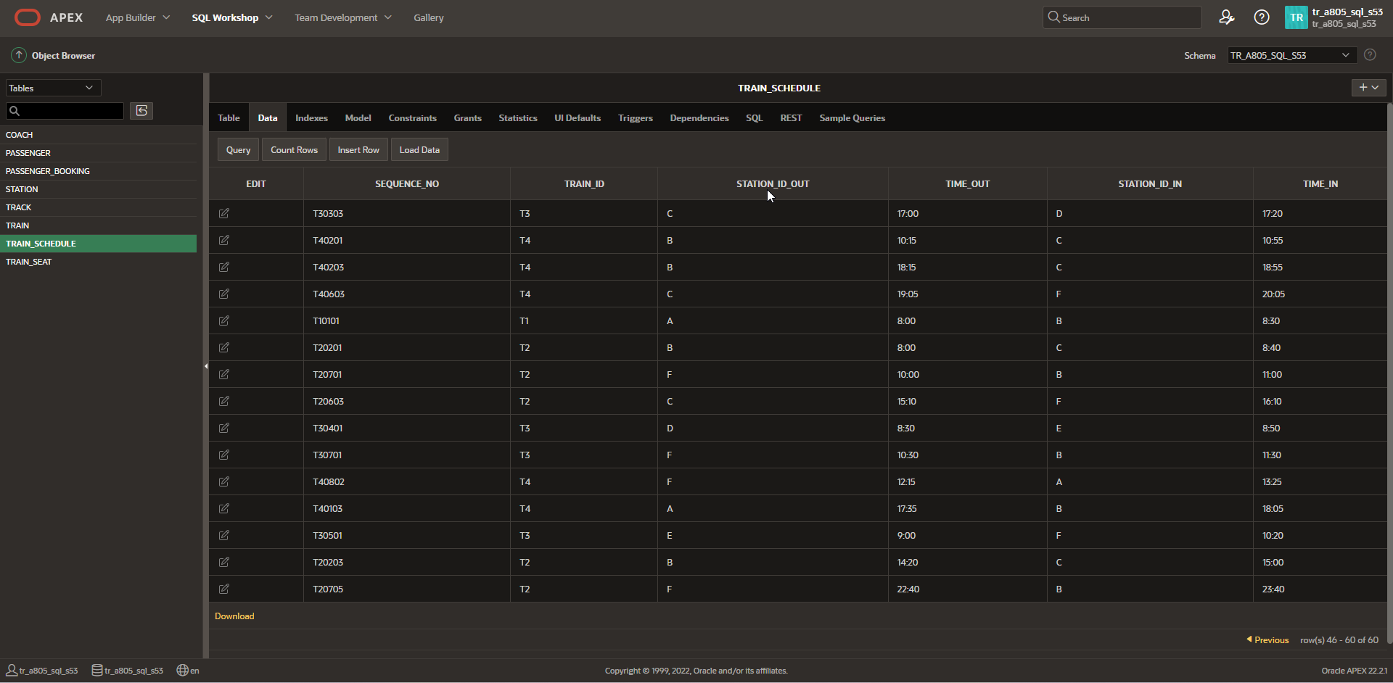

INSERT INTO TRAIN_SCHEDULE VALUES

('T10101','T1','A','8:00','B','8:30');

INSERT INTO TRAIN_SCHEDULE VALUES

('T10201','T1','B','8:40','C','9:20');

INSERT INTO TRAIN_SCHEDULE VALUES

('T10301','T1','C','9:30','D','9:50');

INSERT INTO TRAIN_SCHEDULE VALUES

('T10401','T1','D','10:00','E','10:20');

INSERT INTO TRAIN_SCHEDULE VALUES

('T10501','T1','E','10:30','F','11:50');

INSERT INTO TRAIN_SCHEDULE VALUES

('T10801','T1','F','12:00','A','13:10');

INSERT INTO TRAIN_SCHEDULE VALUES

('T10102','T1','A','13:20','B','13:50');

INSERT INTO TRAIN_SCHEDULE VALUES

('T10202','T1','B','14:00','C','14:40');

INSERT INTO TRAIN_SCHEDULE VALUES

('T10302','T1','C','14:50','D','15:10');

INSERT INTO TRAIN_SCHEDULE VALUES

('T10402','T1','D','15:20','E','15:40');

INSERT INTO TRAIN_SCHEDULE VALUES

('T10502','T1','E','15:50','F','17:10');

INSERT INTO TRAIN_SCHEDULE VALUES

('T10802','T1','F','17:20','A','18:30');

INSERT INTO TRAIN_SCHEDULE VALUES

('T10103','T1','A','18:40','B','19:10');

INSERT INTO TRAIN_SCHEDULE VALUES

('T10203','T1','B','19:20','C','20:00');

INSERT INTO TRAIN_SCHEDULE VALUES

('T10303','T1','C','20:10','D','20:30');

INSERT INTO TRAIN_SCHEDULE VALUES

('T10403','T1','D','20:40','E','21:00');

INSERT INTO TRAIN_SCHEDULE VALUES

('T10503','T1','E','21:10','F','22:30');

INSERT INTO TRAIN_SCHEDULE VALUES

('T10803','T1','F','22:40','A','23:50');

INSERT INTO TRAIN_SCHEDULE VALUES

('T20201','T2','B','8:00','C','8:40');

INSERT INTO TRAIN_SCHEDULE VALUES

('T20601','T2','C','8:50','F','9:50');

INSERT INTO TRAIN_SCHEDULE VALUES

('T20701','T2','F','10:00','B','11:00');

INSERT INTO TRAIN_SCHEDULE VALUES

('T20202','T2','B','11:10','C','11:50');

INSERT INTO TRAIN_SCHEDULE VALUES

('T20602','T2','C','12:00','F','13:00');

INSERT INTO TRAIN_SCHEDULE VALUES

('T20702','T2','F','13:10','B','14:10');

INSERT INTO TRAIN_SCHEDULE VALUES

('T20203','T2','B','14:20','C','15:00');

INSERT INTO TRAIN_SCHEDULE VALUES

('T20603','T2','C','15:10','F','16:10');

INSERT INTO TRAIN_SCHEDULE VALUES

('T20703','T2','F','16:20','B','17:20');

INSERT INTO TRAIN_SCHEDULE VALUES

('T20204','T2','B','17:30','C','18:10');

INSERT INTO TRAIN_SCHEDULE VALUES

('T20604','T2','C','18:20','F','19:20');

INSERT INTO TRAIN_SCHEDULE VALUES

('T20704','T2','F','19:30','B','20:30');

INSERT INTO TRAIN_SCHEDULE VALUES

('T20205','T2','B','20:40','C','21:20');

INSERT INTO TRAIN_SCHEDULE VALUES

('T20605','T2','C','21:30','F','22:30');

INSERT INTO TRAIN_SCHEDULE VALUES

('T20705','T2','F','22:40','B','23:40');

INSERT INTO TRAIN_SCHEDULE VALUES

('T30301','T3','C','8:00','D','8:20');

INSERT INTO TRAIN_SCHEDULE VALUES

('T30401','T3','D','8:30','E','8:50');

INSERT INTO TRAIN_SCHEDULE VALUES

('T30501','T3','E','9:00','F','10:20');

INSERT INTO TRAIN_SCHEDULE VALUES

('T30701','T3','F','10:30','B','11:30');

INSERT INTO TRAIN_SCHEDULE VALUES

('T30201','T3','B','11:40','C','12:20');

INSERT INTO TRAIN_SCHEDULE VALUES

('T30302','T3','C','12:30','D','12:50');

INSERT INTO TRAIN_SCHEDULE VALUES

('T30402','T3','D','13:00','E','13:20');

INSERT INTO TRAIN_SCHEDULE VALUES

('T30502','T3','E','13:30','F','14:50');

INSERT INTO TRAIN_SCHEDULE VALUES

('T30702','T3','F','15:00','B','16:00');

INSERT INTO TRAIN_SCHEDULE VALUES

('T30202','T3','B','16:10','C','16:50');

INSERT INTO TRAIN_SCHEDULE VALUES

('T30303','T3','C','17:00','D','17:20');

INSERT INTO TRAIN_SCHEDULE VALUES

('T30403','T3','D','17:30','E','17:50');

INSERT INTO TRAIN_SCHEDULE VALUES

('T30503','T3','E','18:20','F','19:40');

INSERT INTO TRAIN_SCHEDULE VALUES

('T30703','T3','F','19:50','B','20:50');

INSERT INTO TRAIN_SCHEDULE VALUES

('T30203','T3','B','21:00','C','21:40');

INSERT INTO TRAIN_SCHEDULE VALUES

('T40801','T4','F','8:15','A','9:25');

INSERT INTO TRAIN_SCHEDULE VALUES

('T40101','T4','A','9:35','B','10:05');

INSERT INTO TRAIN_SCHEDULE VALUES

('T40201','T4','B','10:15','C','10:55');

INSERT INTO TRAIN_SCHEDULE VALUES

('T40601','T4','C','11:05','F','12:05');

INSERT INTO TRAIN_SCHEDULE VALUES

('T40802','T4','F','12:15','A','13:25');

INSERT INTO TRAIN_SCHEDULE VALUES

('T40102','T4','A','13:35','B','14:05');

INSERT INTO TRAIN_SCHEDULE VALUES

('T40202','T4','B','14:15','C','14:55');

INSERT INTO TRAIN_SCHEDULE VALUES

('T40602','T4','C','15:05','F','16:05');

INSERT INTO TRAIN_SCHEDULE VALUES

('T40803','T4','F','16:15','A','17:25');

INSERT INTO TRAIN_SCHEDULE VALUES

('T40103','T4','A','17:35','B','18:05');

INSERT INTO TRAIN_SCHEDULE VALUES

('T40203','T4','B','18:15','C','18:55');

INSERT INTO TRAIN_SCHEDULE VALUES

('T40603','T4','C','19:05','F','20:05');

TRAIN

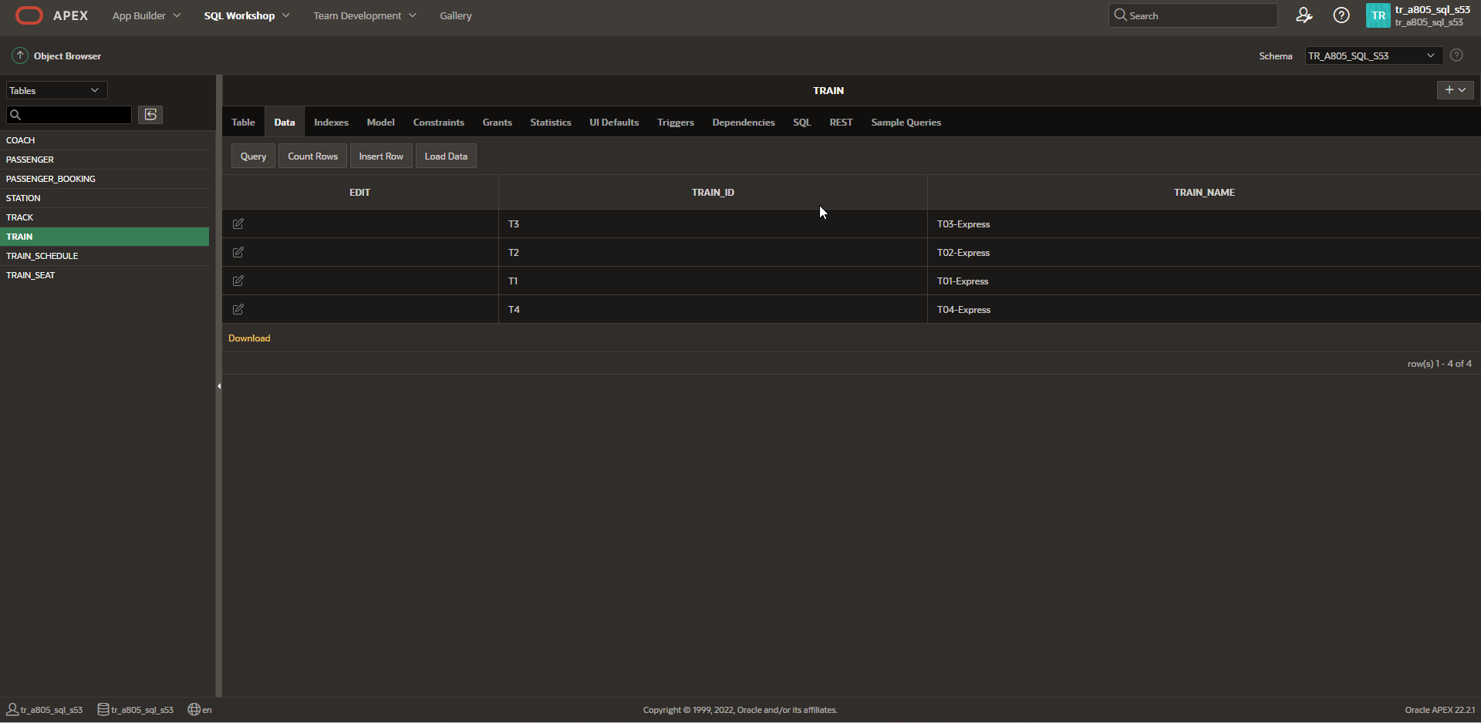

INSERT INTO TRAIN VALUES

('T1','T01-Express');

INSERT INTO TRAIN VALUES

('T2','T02-Express');

INSERT INTO TRAIN VALUES

('T3','T03-Express');

INSERT INTO TRAIN VALUES

('T4','T04-Express');

TRACK

ekran görüntüsü, metin, yazılım, multimedya yazılımı içeren bir resim

Açıklama otomatik olarak oluşturuldu

INSERT INTO TRACK VALUES

(001,'track01','A','B');

INSERT INTO TRACK VALUES

(002,'track02','B','C');

INSERT INTO TRACK VALUES

(003,'track03','C','D');

INSERT INTO TRACK VALUES

(004,'track04','D','E');

INSERT INTO TRACK VALUES

(005,'track05','E','F');

INSERT INTO TRACK VALUES

(006,'track06','C','F');

INSERT INTO TRACK VALUES

(007,'track07','F','B');

INSERT INTO TRACK VALUES

(008,'track08','F','A');

STATION

ekran görüntüsü, metin, yazılım, multimedya yazılımı içeren bir resim

Açıklama otomatik olarak oluşturuldu

INSERT INTO STATION VALUES

('A','Anchorage');

INSERT INTO STATION VALUES

('B','Brampton');

INSERT INTO STATION VALUES

('C','Carlton');

INSERT INTO STATION VALUES

('D','Donahue');

INSERT INTO STATION VALUES

('E','Elderich');

INSERT INTO STATION VALUES

('F','Florida');

PASSENGER_BOOKING

metin, ekran görüntüsü, yazılım, multimedya yazılımı içeren bir resim

Açıklama otomatik olarak oluşturuldu

INSERT INTO PASSENGER_BOOKING (Ticket_ID, Passenger_ID, Booking_date, Train_ID, Psg_Coach_ID, Seat_ID, Start_station_ID, Stop_station_ID) VALUES

(1, 'P001', TO_DATE('01-JAN-2024 21:10', 'DD-MON-YYYY HH24:MI'), 'T1', 1, 102, 'E', 'F');

INSERT INTO PASSENGER_BOOKING (Ticket_ID, Passenger_ID, Booking_date, Train_ID, Psg_Coach_ID, Seat_ID, Start_station_ID, Stop_station_ID) VALUES

(2, 'P002', TO_DATE('02-JAN-2024 13:20', 'DD-MON-YYYY HH24:MI'), 'T1', 2, 108, 'A', 'B');

INSERT INTO PASSENGER_BOOKING (Ticket_ID, Passenger_ID, Booking_date, Train_ID, Psg_Coach_ID, Seat_ID, Start_station_ID, Stop_station_ID) VALUES

(3, 'P003', TO_DATE('03-JAN-2024 22:40', 'DD-MON-YYYY HH24:MI'), 'T1', 3, 111, 'F', 'A');

INSERT INTO PASSENGER_BOOKING (Ticket_ID, Passenger_ID, Booking_date, Train_ID, Psg_Coach_ID, Seat_ID, Start_station_ID, Stop_station_ID) VALUES

(4, 'P004', TO_DATE('04-JAN-2024 09:30', 'DD-MON-YYYY HH24:MI'), 'T1', 4, 117, 'C’, 'D');

INSERT INTO PASSENGER_BOOKING (Ticket_ID, Passenger_ID, Booking_date, Train_ID, Psg_Coach_ID, Seat_ID, Start_station_ID, Stop_station_ID) VALUES

(5, 'P005', TO_DATE('01-JAN-2024 16:20', 'DD-MON-YYYY HH24:MI'), 'T2', 6, 204, 'F’, 'B');

INSERT INTO PASSENGER_BOOKING (Ticket_ID, Passenger_ID, Booking_date, Train_ID, Psg_Coach_ID, Seat_ID, Start_station_ID, Stop_station_ID) VALUES

(6, 'P006', TO_DATE('02-JAN-2024 20:40', 'DD-MON-YYYY HH24:MI'), 'T2', 7, 207, 'B', 'C');

INSERT INTO PASSENGER_BOOKING (Ticket_ID, Passenger_ID, Booking_date, Train_ID, Psg_Coach_ID, Seat_ID, Start_station_ID, Stop_station_ID) VALUES

(7, 'P007', TO_DATE('03-JAN-2024 15:10', 'DD-MON-YYYY HH24:MI'), 'T2', 8, 213, 'C’, 'F');

INSERT INTO PASSENGER_BOOKING (Ticket_ID, Passenger_ID, Booking_date, Train_ID, Psg_Coach_ID, Seat_ID, Start_station_ID, Stop_station_ID) VALUES

(8, 'P008', TO_DATE('03-JAN-2024 08:50', 'DD-MON-YYYY HH24:MI'), 'T2', 9, 218, 'C', 'F');

INSERT INTO PASSENGER_BOOKING (Ticket_ID, Passenger_ID, Booking_date, Train_ID, Psg_Coach_ID, Seat_ID, Start_station_ID, Stop_station_ID) VALUES

(9, 'P009', TO_DATE('01-JAN-2024 13:00', 'DD-MON-YYYY HH24:MI'), 'T3', 11, 305, 'D', 'E');

INSERT INTO PASSENGER_BOOKING (Ticket_ID, Passenger_ID, Booking_date, Train_ID, Psg_Coach_ID, Seat_ID, Start_station_ID, Stop_station_ID) VALUES

(10, 'P010', TO_DATE('01-JAN-2024 18:20', 'DD-MON-YYYY HH24:MI'), 'T3', 12, 307, 'E', 'F');

INSERT INTO PASSENGER_BOOKING (Ticket_ID, Passenger_ID, Booking_date, Train_ID, Psg_Coach_ID, Seat_ID, Start_station_ID, Stop_station_ID) VALUES

(11, 'P011', TO_DATE('01-JAN-2024 19:50', 'DD-MON-YYYY HH24:MI'), 'T3’, 13, 315, 'F’, 'B');

INSERT INTO PASSENGER_BOOKING (Ticket_ID, Passenger_ID, Booking_date, Train_ID, Psg_Coach_ID, Seat_ID, Start_station_ID, Stop_station_ID) VALUES

(12, 'P012', TO_DATE('03-JAN-2024 17:00', 'DD-MON-YYYY HH24:MI'), 'T3', 14, 316, 'C', 'D');

INSERT INTO PASSENGER_BOOKING (Ticket_ID, Passenger_ID, Booking_date, Train_ID, Psg_Coach_ID, Seat_ID, Start_station_ID, Stop_station_ID) VALUES

(13, 'P013', TO_DATE('02-JAN-2024 09:35', 'DD-MON-YYYY HH24:MI'), 'T4', 16, 403, 'A', 'B');

INSERT INTO PASSENGER_BOOKING (Ticket_ID, Passenger_ID, Booking_date, Train_ID, Psg_Coach_ID, Seat_ID, Start_station_ID, Stop_station_ID) VALUES

(14, 'P014', TO_DATE('05-JAN-2024 11:05’, 'DD-MON-YYYY HH24:MI'), 'T4', 17, 407, 'C', 'F');

INSERT INTO PASSENGER_BOOKING (Ticket_ID, Passenger_ID, Booking_date, Train_ID, Psg_Coach_ID, Seat_ID, Start_station_ID, Stop_station_ID) VALUES

(15, 'P015', TO_DATE('01-JAN-2024 10:15', 'DD-MON-YYYY HH24:MI'), 'T4', 18, 411, 'B', 'C');

PASSENGER

ekran görüntüsü, metin, yazılım, multimedya yazılımı içeren bir resim

Açıklama otomatik olarak oluşturuldu

INSERT INTO PASSENGER VALUES

(‘P001’, ‘Yunus’, ‘Cakici’, ‘Male’);

INSERT INTO PASSENGER VALUES

(‘P002’, ‘Enes’, ‘Aksoy’, ‘Male’);

INSERT INTO PASSENGER VALUES

(‘P003’, ‘Bedirhan’, ‘Celik’, ‘Male’);

INSERT INTO PASSENGER VALUES

(‘P004’, ‘Gizem’, ‘Yılmaz’, ‘Female’);

INSERT INTO PASSENGER VALUES

(‘P005’, ‘Sude’, ‘Koroglu’, ‘Female’);

INSERT INTO PASSENGER VALUES

(‘P006’, ‘Berru’, ‘Uludag’, ‘Female’);

INSERT INTO PASSENGER VALUES

(‘P007’, ‘Baran’, ‘Oner’, ‘Male’);

INSERT INTO PASSENGER VALUES

(‘P008’, ‘Arda’, ‘Colak’, ‘Male’);

INSERT INTO PASSENGER VALUES

(‘P009’, ‘Cafer, ‘Selvi’, ‘Male’);

INSERT INTO PASSENGER VALUES

(‘P010’, ‘Emre’, ‘Cakir’, ‘Male’);

INSERT INTO PASSENGER VALUES

(‘P011’, ‘Emirhan’, ‘Pamuk’, ‘Male’);

INSERT INTO PASSENGER VALUES

(‘P012’, ‘Ebubekir’, ‘Meric’, ‘Male’);

INSERT INTO PASSENGER VALUES

(‘P013’, ‘Ali’, ‘Ozsoy’, ‘Male’);

INSERT INTO PASSENGER VALUES

(‘P014’, ‘Fatma’, ‘Ozturk’, ‘Female’);

INSERT INTO PASSENGER VALUES

(‘P015’, ‘Arda’, ‘Guler’, ‘Male’);

COACH

ekran görüntüsü, metin, yazılım, multimedya yazılımı içeren bir resim

Açıklama otomatik olarak oluşturulduekran görüntüsü, metin, multimedya yazılımı, yazılım içeren bir resim

Açıklama otomatik olarak oluşturuldu

INSERT INTO COACH (CoachID, Capability, TrainID, Food, Music, Drink)

VALUES

(1, 5, ’T1’, ’Steak’, ’Live is Life’, ’Red Wine’);

INSERT INTO COACH (CoachID, Capability, TrainID, Snack)

VALUES

(2, 5, ‘T1’, ‘Biscuit’);

INSERT INTO COACH (CoachID, Capability, TrainID, Snack)

VALUES

(3, 5, ‘T1’, ‘Biscuit’);

INSERT INTO COACH (CoachID, Capability, TrainID, Snack)

VALUES

(4, 5, ‘T1’, ‘Biscuit’);

INSERT INTO COACH (CoachID, Capability, TrainID, Snack)

VALUES

(5, 5, ‘T1’, ‘Biscuit’);

INSERT INTO COACH (CoachID, Capability, TrainID, Food, Music, Drink)

VALUES

(6, 5, ’T2’, ’Brocoli’, ’Beggin’, ’White Wine’);

INSERT INTO COACH (CoachID, Capability, TrainID, Snack)

VALUES

(7, 5, ‘T2’, ‘Biscuit’);

INSERT INTO COACH (CoachID, Capability, TrainID, Snack)

VALUES

(8, 5, ‘T2’, ‘Biscuit’);

INSERT INTO COACH (CoachID, Capability, TrainID, Snack)

VALUES

(9, 5, ‘T2’, ‘Biscuit’);

INSERT INTO COACH (CoachID, Capability, TrainID, Snack)

VALUES

(10, 5, ‘T2’, ‘Biscuit’);

INSERT INTO COACH (CoachID, Capability, TrainID, Food, Music, Drink)

VALUES

(11, 5, ’T3’, ’Meetballs’, ’Another Love’, ’Cola’);

INSERT INTO COACH (CoachID, Capability, TrainID, Snack)

VALUES

(12, 5, ‘T3’, ‘Biscuit’);

INSERT INTO COACH (CoachID, Capability, TrainID, Snack)

VALUES

(13, 5, ‘T3’, ‘Biscuit’);

INSERT INTO COACH (CoachID, Capability, TrainID, Snack)

VALUES

(14, 5, ‘T3’, ‘Biscuit’);

INSERT INTO COACH (CoachID, Capability, TrainID, Snack)

VALUES

(15, 5, ‘T3’, ‘Biscuit’);

INSERT INTO COACH (CoachID, Capability, TrainID, Food, Music, Drink)

VALUES

(16, 5, ’T1’, ’Pizza’, ’Lovely’, ’Sprite’);

INSERT INTO COACH (CoachID, Capability, TrainID, Snack)

VALUES

(17, 5, ‘T1’, ‘Biscuit’);

INSERT INTO COACH (CoachID, Capability, TrainID, Snack)

VALUES

(18, 5, ‘T1’, ‘Biscuit’);

INSERT INTO COACH (CoachID, Capability, TrainID, Snack)

VALUES

(19, 5, ‘T1’, ‘Biscuit’);

INSERT INTO COACH (CoachID, Capability, TrainID, Snack)

VALUES

(20, 5, ‘T1’, ‘Biscuit’);